Squirrels’ Homework
Autumn term
Week 5
Happy Friday Squirrels!
A great response to homework Squirrels. Thank you and well done.
Please see below for this week’s homework.
Literacy
We are continuing with text type persuasive text.
Homework this week please:
Year 3 explain to a grown up what a rhetorical question is and then write one. Remember your punctuation at the end of a question please Y3. You wouldn’t want to forget now, would you?
Year 2 Think about all the nouns you use or see around you. How would you describe these? What adjectives (describing words) could you use to describe all the nouns (person, place or thing) you notice?
For example: A hot dinner; A fast and shiny car; My new shoes; A bright morning; The fluffy cat.
Year 2 and Year3, using imperative verbs (bossy verbs) and including an (ly) adverb I would like you to practice writing a few sentences.
For example:
Go to the bank swiftly as we have a lot to do!
Chop the vegetables quickly but carefully.
Dance gracefully across the room.
Run energetically as fast as you can.
You must include an imperative verb and an adverb.
You will include: capital letters, full stops, finger spaces. In addition, Y3: exclamation marks or questions marks.
Things you will try to include: adjectives, conjunctions: and, but, so, if, or, for, nor, yet. In addition, Y3: since, before, although, if, as, while, after, before, until, because, when.
Maths
Column addition without renaming (by this we do not add more then 9 in any column – yet!)
Year 3, 3 digit numbers.
Year 2, 2 digit numbers.

Maths homework this week:
Year 2
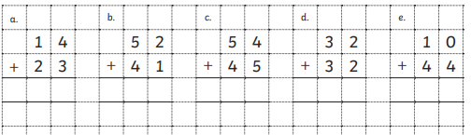
Year 3
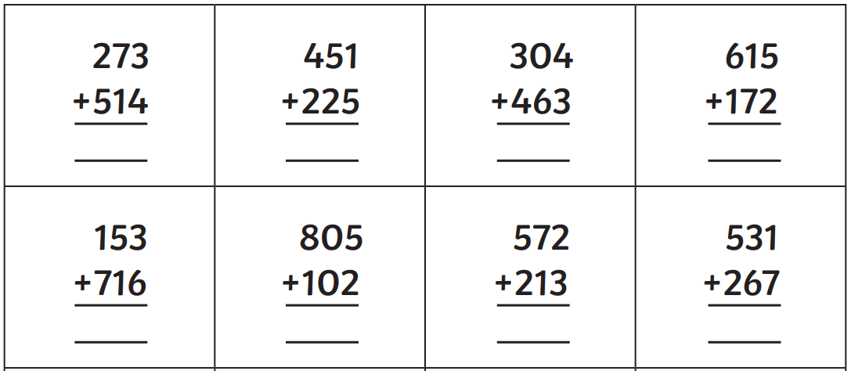

In addition…
Children have enjoyed using iPads in school as additional maths practice. We have been using doodle maths and TT Rock Stars.
I have sent home logins this week which have your child’s username and password for both:
TT rock stars: https://ttrockstars.com/ and Doodle maths: https://doodlelearning.com/
Y3 children also came home with some words to practice for their Harvest Festival.
Y2 children will also be taking part in the Harvest Festival. They have a special role which they are practicing in class.
Have a wonderful weekend everyone!
With warm wishes,
Miss Swain and Daphne

