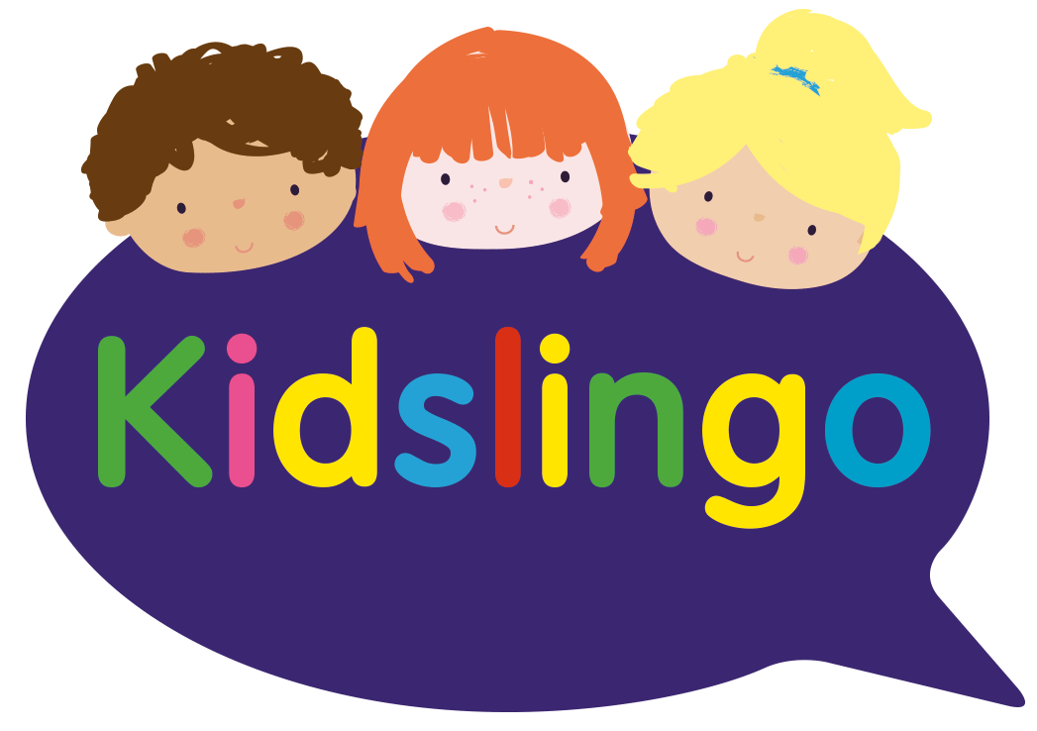
Kidslingo French at Whaddon C of E First School

French After School club -Mondays, 3-4pm

There are limited places which will be allocated on a first come first served basis. To reserve your place, please email me at laura.langley@kidslingo.co.uk

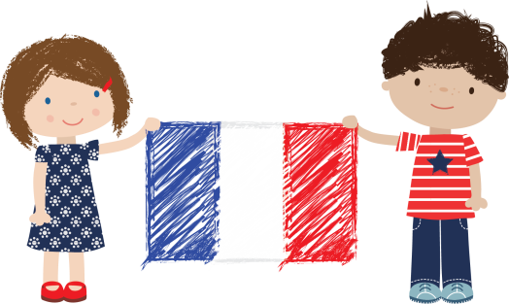
Learning a language at a young age helps children to grow in self-confidence and boosts their natural creativity. There is a fantastic window of opportunity during early years development where children can absorb a language without even realising it!

At Kidslingo, we are dedicated to teaching French to children through fun.
We use stories, games, songs, crafts and drama to bring the language to life and inspire our learners, focusing on a different fun topic each half term.

- 1 hour classes on Mondays 3:00pm-4:00pm
- £5.00 per week – sign up for a term at a time. Existing customers will have priority at renewal for the next term’s classes
- We will issue vocabulary sheets, provide reward certificates and worksheets

If you would like to register, please email me and I will send you details for payment to secure your child’s place.

Please book early to avoid disappointment.

If you have any questions and to register, please email me at laura.langley@kidslingo.co.uk

