Hedgehog Class Weekly Update 29th September 2022

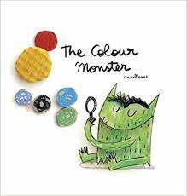
Language and Literacy
Using The Colour Monster book, we are continuing to explore feelings as well as imagining what a monster’s party might be like. This has led to lots of talk and writing opportunities, such as lists and invitations. Using our phonic skills to hear rhyming words and
create word strings has been fun too.
Maths
We have worked on recognising and splitting groups of objects in Maths – which is great for developing understanding for calculations. We have been finding equal and unequal sets, with Year 1 investigating how many ways they can do this with different numbers to 10.
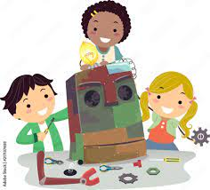
Art and Design
Junk model day was amazing! We were really impressed with the models created and the skills in involved to design, cut, stick, review and describe what was made. Thank you for supplying the ‘junk’ resources to make this happen.
There were also special painting and drawing tasks led by Friends of Whaddon volunteers that will provide artwork for fundraising projects.
Science / Music
Music and sounds have also been a big feature this week as we investigated sounds around us, rhythms on instruments and learning a harvest song.

Next Week
- RE/Key Theme: Learning about what Harvest is and being thankful for food
- Key Story: Tattyboggle by Sandra Horn about a scarecrow and the seasons
- Year 1 Maths: Composition of numbers – how numbers to 10 can be shown as sets
- Year R Maths: Counting sets of objects and recognising numbers
- Year 1 Phonics – cvcc and ccvc words (c= consonant, v = vowel) as we start Phase 4
- Year R Phonics – introducing phonics sounds s a t p as we start Phase 2
If you are new to supporting your child with learning phonics, please click on the useful links and information on the Phonics area of this webpage.

