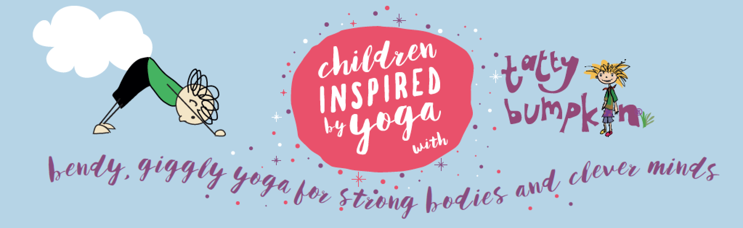

Yoga Inspired Activity Club

Come and join us for Tatty Bumpkin Yoga club which will be running on Tuesday Afternoons 3.00pm – 4.00pm, from Tuesday 8th January to Tuesday 12th February 2019 inclusive.

What is a Tatty Bumpkin class?
Tatty Bumpkin is a character doll who goes on imaginative adventures (i.e. into space and under the sea, or to the Jungle) and the sessions use yoga positions to tell the story. They are active sessions and great for sporty kids as well as those who enjoy a more creative approach to movement. Each session is fun and motivating, encouraging the children engage in active stories. Through specifically written songs and moves, they will learn new ways to stretch and learn.
The children will have the opportunity to:
Learn yoga positions that enhance their posture, increase physical strength and ability to learn
Learn how to relax and deal with everyday anxieties.
Think creatively along with the stories
The class is inclusive and non-competitive and ideal for all children. The Tatty Bumpkin programme has been devised by yoga teachers, paediatric physiotherapists, educational and special needs therapists, musicians and children’s authors.

Why Yoga at School?
Yoga helps to maintain children’s innate flexibility and develop muscular strength and endurance, providing them with a very different experience and giving variety to their day. Equally important is the fact that yoga improves mental focus, imagination, self-belief and a sense of fun. This serves to build a strong foundation for children to expand their confidence, become aware of their body, and learn new skills. Doing classes together with their friends helps everyone to have fun and releases tension whilst helping them to concentrate on their schoolwork.
The classes cost £27.00 for the 6 week term. Spaces are limited to 15 children. This includes a weekly sticker and termly certificate. If you would like to enrol your child in the next term, please email me directly:
northbucks@tattybumpkin.com. Confirmation and details of how to pay will then be emailed to you. More info: www.tattybumpkin.com/northbucks
Kind regards,
Julie Pearson

