Hedgehog Class Weekly Update 3rd October 2022
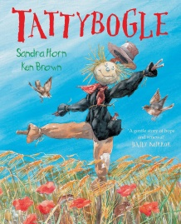
Language and Literacy
The story of Tattyboggle by Sandra Horn has led to exploring themes of Seasons and Farming. We have been using words about the weather to describe pictures and the natural world around us, as well as talking about the changes that happen to the Scarecrow character. You can watch the story again here:
https://www.youtube.com/watch?v=j_Jye-71VhE
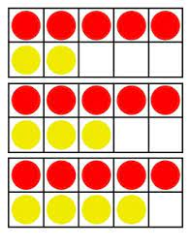
Maths
Reception have continued work on counting groups of objects accurately – teaching a dragon puppet how to do this! Year 1 continue splitting groups of objects in Maths as they develop understanding and rapid recall of calculations. We have been finding ways of adding on to 5 to make other totals using different types of ten frames.

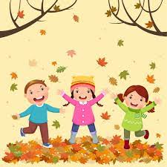
Science / Art and Design / Music
We began the week with an Autumn walk around the grounds looking at all the seasonal changes and gathering objects that show this. We talked about the different types of plants and crops that we see around us and began discussing what animals need to do in Autumn to prepare for Winter.
Exploring the colours of the season with paint and using collage / junk materials to create our own scarecrows and singing harvest and scarecrow songs have made this week full of Autumn colour and creativity.

Next Week
- RE/Key Theme: Learn about Harvest; being thankful for food, writing a class prayer
- Key Story: The Little Red Hen (traditional tale) about making bread and helping each other
- Year 1 Maths: Composition of numbers – how numbers to 10 can be shown as sets
- Year R Maths: Counting sets of objects and recognising numbers
- Year 1 Phonics – cvcc and ccvc words (c= consonant, v = vowel) in Phase 4
- Year R Phonics – introducing phonics sounds i n m d in Phase 2
If you are new to supporting your child with learning phonics, please click on the useful links
and information on the Phonics area of this webpage.

Come and Join Us!
You are welcome to join us for
Stay and Play Phonics Session for RECEPTION families/carers
Thursday 13th October 8.50-10am in school
Harvest Festival for all families/carers:
Monday 17th October 2pm at St Mary’s Church, Whaddon

