Friday 13th May
Happy Friday Squirrels,

It has been a wonderful week in the Squirrel’s classroom.
Homework for this week please Squirrels:
Maths:
This week in maths we have been learning to tell the time beginning with the facts that there are 60 seconds in a minute and 60 minutes in one hour.
We have looked at am or pm, o’clock, half past, quarter past and quarter to the hour. Quarter to the hour proved quite tricky for most children. We began to look at the relationship between 5-minute intervals (Y2) and 1-minute intervals (Y3) e.g. 3.05 or 3.01.
Your maths homework this week is to practice telling and writing the time using an analogue clock with accuracy to
5 minutes (Y2) and 1 minute (Y3)
e.g. (Y3) 6.17pm or 7.29am
(Y2) 6.25pm or 4.40am etc..

Literacy:
This week the children have been writing fact files in literacy using iPads to research facts.

For your literacy homework this week I would like you to write a paragraph or two about a topic of your choice. Remember the features you need to include in a fact file.
Mantle:
Our Mantle topic is beginning to take shape. The children empathised with the Londoners of 1666 when the Great Fire of London destroyed the city. When stepping into the Mantle story, children became Londoners’ of 1666. They have agreed that they wish to begin to rebuild the city.
This week we have looked at the key events of the Great Fire of London and the trades people that would have been around during this period.
Please encourage your child to discuss the order in which the events unfolded and the trades people that were around back then.
See below for the order of events.
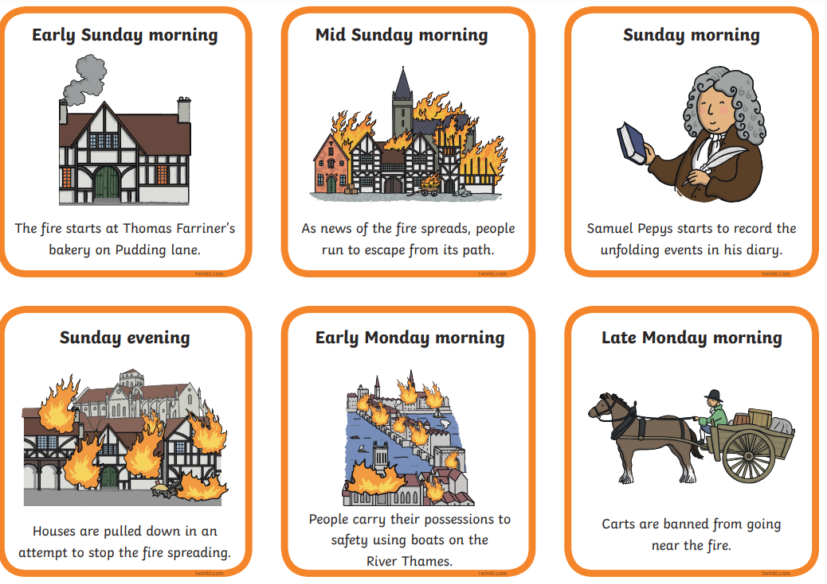
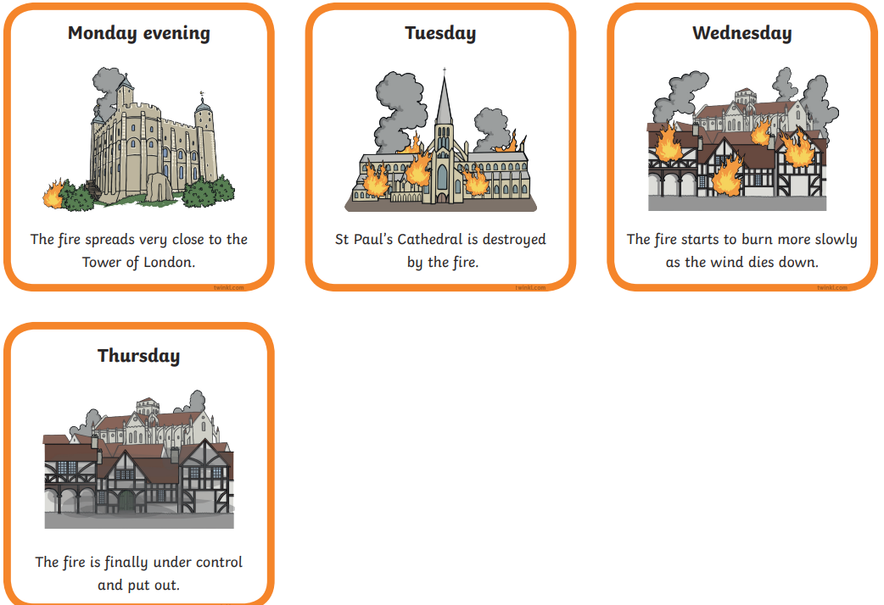
Please continue to practice reading for 10 minutes each day.
Also, please continue to practice spelling number words from one – twenty.
Keep up the great work Squirrels.
Wishing you all a wonderful weekend,
From Miss Swain and Daphne

