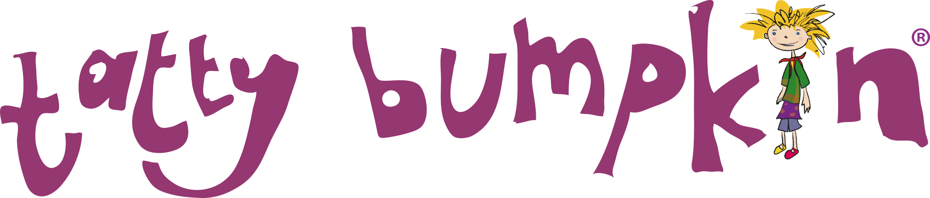

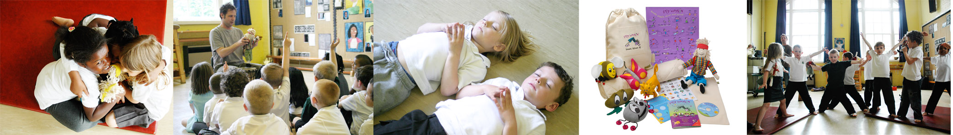
We are excited to offer Tatty Bumpkin YOGA inspired after school club which will be running onTuesday afternoons from 3-4pm –

What is a Tatty Bumpkin class?
Tatty Bumpkin classes use yoga positions within a story format. They are active sessions and great for sporty kids as well as those that enjoy a more creative approach to movement. Each session is fun and motivating, encouraging the children engage in active stories. Through specifically written songs and moves, they will learn new ways to stretch and learn.
The children will have the opportunity to:
Learn yoga positions that enhance their posture, increase physical strength and ability to learn
Learn how to relax and deal with everyday anxieties.
Think creatively along with the stories
The class is inclusive and non-competitive and ideal for all children
The Tatty Bumpkin programme has been devised by yoga teachers, paediatric physiotherapists, educational and special needs therapists, musicians and children’s authors.

Why Yoga?
Yoga helps to maintain children’s innate flexibility and develop muscular strength and endurance, providing them with a very different experience and giving variety to their day. Equally important is the fact that yoga improves mental focus, imagination, self-belief and a sense of fun. This serves to build a strong foundation for children to expand their confidence, become aware of their body, and learn new skills. Doing classes together with their friends helps everyone to have fun and releases tension whilst helping them to concentrate on their schoolwork.
I and my teachers have a CACHE (Council for Awards in Childcare, Health and Education) certification, and we are fully DBS checked.
To enroll on the club, please Email me – northbucks@tattybumpkin.com for a registration form and how to pay.
I look forward to working with your children and helping them to explore their physicality and creativity, providing them with life skills for the future, and most importantly HAVING FUN.
Kind Regards,
Julie Pearson
If you would like more information I can be contacted on 07745 301624 or by email: northbucks@tattybumpkin.com and further information can also be found on my website: www.tattybumpkin.com/northbucks

