How you can help your child

*Always encourage your child to write on a line, even if they must draw it themselves. This helps them to orientate their letters and recognise where they begin.

*For Foundation stage children, your child’s teacher will advise you when they are ready to begin to form their letters and which letters to begin with. It is just as important to practise drawing patterns such as: circles, arches, lines, zigzags and hooks. These will help your child develop pencil control, as will the following activities:

_ colouring-in activities,

_ tracing,

_ drawing around shapes, templates,

_ making letter shapes in playdough, in sand,

on white-boards etc. (not just on paper,)

_ painting, using finger paints or brushes.

Make it fun!

*when they can form their letters, encourage your child to use cursive writing in any writing they produce.

**Handwriting Guide for Parents**

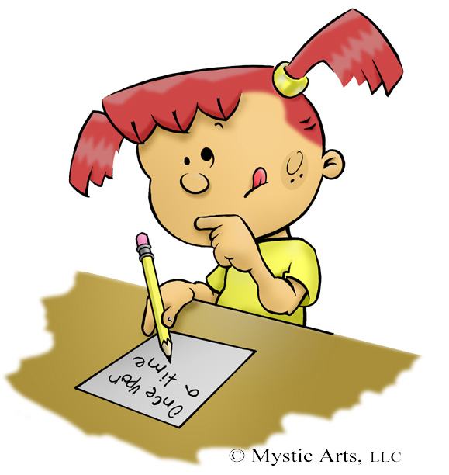

Cursive Handwriting

This leaflet is to explain how and why we teach handwriting at Whaddon First School. It also includes ideas on ways you can help to develop your child’s handwriting.

Your child will be taught to develop a cursive handwriting style that progresses smoothly from initial cursive letter formation to joined fluency.

Research has shown that it is often difficult for children to change from printed to joined script in. Cursive script joins all letters except capital letters and all individual letters start on the line, making the progression to joining writing very natural and children will often start to join their letters without realising.

When writing, even in Foundation, children will be encouraged to draw a line to write on. Handwriting will not only be taught in isolation but as an integral part of all aspects of writing and spelling. Using a cursive script aids spelling as the children don’t lift their pencil off the page until the end of the word.

Teaching the letters

*We model cursive writing whenever we are with the children and display it, and other font types, in the class

*We include it as part of the daily phonic session and always join the letters that make each sound

*We write comments on work in cursive, joined writing.

*In Foundation, when the children begin to try to form letters for themselves, we will then introduce new letters each week, always revisiting ‘old’ letters

*In years 1 and 2, we teach groups of similar letters (see image below) making

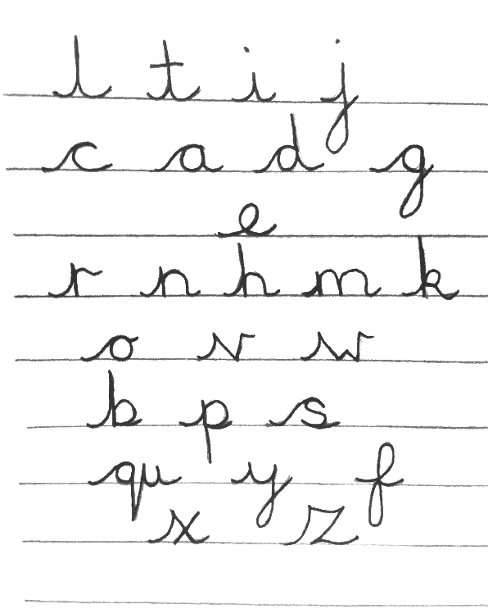

sure they are used in words e.g. teach c,a,d,g and practise the words cad, dag,