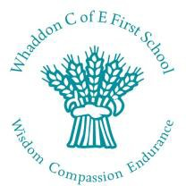

End of year results 2018

% of Foundation Stage to achieve a Good Level of Development
School 2018 | National 2017
76% | 70%

% of Year 1 to pass Phonics screening check
School 2017 | National 2016
94% | 81%

*No retakes were needed in Year 2

% of Year 2 to achieve expected standard & greater depth in core subjects
Key Stage 1 Outcomes | School 2017 | National 2016
expected standard in reading | 100% | 76%
expected standard in writing | 87% | 68%
expected standard in maths | 100% | 75%
expected standard in science | 100% | 83%
greater depth in reading | 50% | 25%
greater depth in writing | 37% | 16%
greater depth in maths | 62% | 21%

Whaddon Church of England first school, Whaddon, Milton Keynes, MK17 0LS

Head: Mrs Selina Davies B Ed (hons)
T 01908 501719 E office@whaddon.bucks.sch.uk
whaddon.eschools.co.uk

