Hedgehog Class Weekly Update Week Beg: 10th October
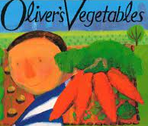
Language and Literacy
The story of Oliver’s Vegetables by Alison Bartlett and Vivian French has led to exploring themes of Food and Farming. You can watch a video of it here: https://www.youtube.com/watch?v=axu1ZCZynRg
We have been using words about the different types of food we enjoy and where they come from (gardens, farms, the sea etc). There have been opportunities for role play meals / cafes where we have written our own menus and orders.

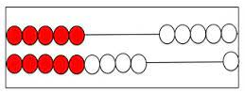
Maths
Reception have continued work on making and counting groups accurately by collecting and comparing groups of objects. Year 1 continue splitting groups of objects in Maths as they develop understanding and rapid recall of calculations. We have been using rekenrek – a type of abacus to identify ways to make 10.
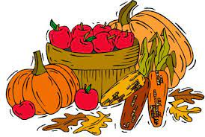
Science / Art and Design / Music / RE
We enjoyed talking about our favourite kinds of food in circle times have used the ideas to create a class prayer of to say thank you for our food and those who help provide it. We’ve been working on some pictures to illustrate our prayer too. We look forward to sharing these along with our fun Bean Harvest song at the Harvest Festival next week.

Next Week
- Key Theme/PHSE: Learn about the importance of team work and helpfulness
- Key Story: The Little Red Hen (traditional tale) about making bread
- Year 1 Maths: Comparison of sets of objects – using more / fewer / equal vocabulary
- Year R Maths: Counting sets of objects, splitting/remaking sets and recognising numbers
- Year 1 Phonics – cvcc and ccvc words (c= consonant, v = vowel) in Phase 4
- Year R Phonics – introducing phonics sounds g o c k in Phase 2
- RE – Learn about Sukkot; a Jewish harvest celebration
If you are new to supporting your child with learning phonics, please click on the useful links
and information on the Phonics area of this webpage.
Come and Join Us!
You are welcome to join us at
Whole School Harvest Festival - all families/carers invited:
Monday 17th October 2pm at St Mary’s Church, Whaddon
Donations of tinned/dried produce for Milton Keynes Food Bank are being collected before / after school. Thank you.

Thank you to the families who joined us for Phonics Stay & Play this week.
We aim to run further sessions throughout the year and will inform you of the dates as soon as we can to enable more of you to join us – including some with Year 1.

