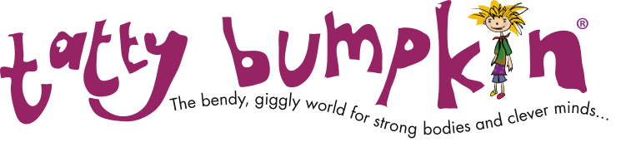

Tatty Bumpkin Yoga Inspired Activity Class Registration Form

Your Child’s Full Name:
Boy □ Girl □ | Date of Birth:
Parent/Guardian’s Full name: | Address:  Postcode:
Contact number:
Email address:
In the case of emergency please provide a second guardian’s details
Name:  Contact number: | Address:
Any health problems or other information you would like to tell me:

Please return this completed booking form to the email address below, together with your payment - cash or cheque for £36.00 (8 weeks) made payable to Tatty Bumpkin North Bucks, or by bank transfer to 23-05-80 16569453.

P.S. Please remember to sign the disclaimer over the page.
Disclaimer for Tatty Bumpkin classes

All Tatty Bumpkin teachers have passed our CACHE (Council for Awards in Care, Health and Education) accredited training programme, have a full DBS check in relation to working with children and are fully insured. Tatty Bumpkin has up-to-date policies on safe-guarding children and risk assessments.

Health
You must inform the Tatty Bumpkin teacher of any pre-existing medical conditions that your child has prior to the start of the Tatty Bumpkin classes. You must also inform the Tatty Bumpkin teacher of any medical condition diagnosed following the start of the sessions.

What to bring/wear
It’s hard work being Bendy, Giggly, Clever and Strong so it is a good idea if children have a drink of water before and after class. We will be removing our socks/tights and shoes. If classes are held in school, children can wear comfortable clothing of their choice or remain in school uniform.

Liability disclaimer and notice
Tatty Bumpkin Classes are fun and physical and may involve movements your child doesn’t usually make. Every care is taken to ensure that the Tatty Bumpkin classes and the venue are safe. Tatty Bumpkin cannot accept responsibility for any injury suffered by your child by reason of having taken part in Tatty Bumpkin classes, which are undertaken entirely at your own risk. If you have any concerns as to whether your child is able to undertake Tatty Bumpkin classes please talk to me directly, or consult your doctor. Occasionally, to show your child the correct way of doing a posture, it can help if the teacher assists. This is never more than a guiding hand. You agree that your child is fit enough not to suffer any harm as a result of such intervention and that we will not be liable for giving this assistance.

I understand that the classes are held under the supervision of a Tatty Bumpkin qualified teacher. I accept full responsibility for the actions of my child during the class. In a setting where I am not present I entrust staff with the care of my child and discharge and hold harmless Tatty Bumpkin Ltd, its owners, officers and personnel, including its franchisees, teachers and its suppliers for any liability arising from any injury to my child or other persons or property caused by my child’s participation in the Tatty Bumpkin programme.

☐ Check this box if you wish to receive newsletters, or offers from Tatty Bumpkin (we will never pass your information onto a third party.) We will only use your email address to inform you of specific class information relating to Whaddon C of E School.

Parent/Guardian Name: _______________________

Signature: _______________________________ Date: _______________________

